**Mathematical Model of Interacting Fidget Spinners**

Isabella Lin

**Abstract**

A Magnetic Gear showcases an interplay of forces in response to a rotating fidget spinner (driving) to a rotating spinner (driven) without touching. There are neodymium magnets attached to the ends of every spinner. A mathematical model of magnetically coupled fidget spinners is studied in which magnetic forces are modeled based on a torque that is linear in the angular separation of the spinner arms. We found that the total angular momentum of the system varies over time. In addition, the effect of a frictional dissipation term on both the angular momentum and kinetic energy over time is examined.

**Introduction**

Magnetic Gears, also known as Magnetic Transmission, is a type of gear system where there is no contact between the gears, and the driving forces would be the interactions of the magnets on all gears. These systems demonstrate an interaction between magnetic fields and rotating objects.

There are many different types of interesting behavior discovered through early experimentation. The first type of behavior is where one spinner has excessive angular speed, resulting in a lack of transmitted energy to the other spinner. The other type of behavior is when a spinner is slowing down, and it “locks” onto the driven spinners, allowing them to rotate synchronously due to the magnetic fields of the spinners. Another type of observed behavior is when the spinners oscillate back and forth, before eventually reaching equilibrium and coming to a stop.

We have also observed that angular momentum is not conserved through early experimentation. This has led us to create a mathematical model to represent this phenomenon. We have created two types of mathematical models; One is using a linear model of torque based on angular separation of spinner arms, while the other is using “magnetic charges” on two ends of a magnet.

**Method**

At first, we didn’t know that the torque of spinner hands was linear based on the angle separation. Our goal was to determine a mathematical form of the potential energy causing interaction between the two spinners, so we started by trying to find a torque function based on the angular separation of the hands of the spinners.

*Fig. 1: Setup to measure torque between two magnets by varying both angles.*

Our setup involves two rotatable bars fixed on a table with clamps. There is a weight on top of the upper magnet to vary the forces to measure the torque between two magnets. From our data points of the torque based on the two angles, we came up with a linear fit. Fig F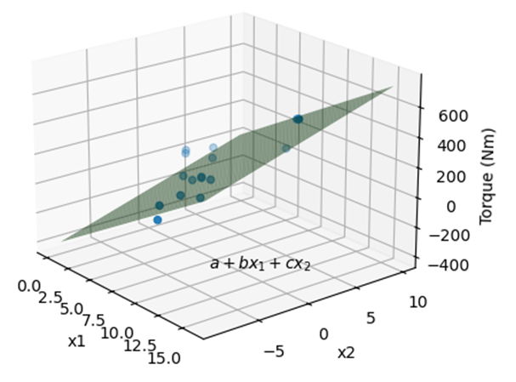

*Fig. 2: Linear fit of torque based on the two angles.*

From the fit, we find that the torque based on the two points can be modeled based on the equation 1:

T(theta1,theta2) = a + btheta1 + ctheta2

However, theta1 and theta2 should be symmetric and therefore have no difference in weight. Thus, we hypothesize that the torque function can be written as equation 2:

T(theta1,theta2) = k(theta1 + theta2 + c)

Where k and c are constants.

For convenience in modeling, we replaced the constant c with pi, hence giving our final torque in equation 3.

T(theta1,theta2) = k(theta1 + theta2 + pi)

From equation 3, we can integrate the function to obtain a potential energy function in equation 4.

PE(theta1,theta2) = 1/2k(theta1 + theta2 + pi)^2

Because we have 3 arms in total per spinner and not just one, we have to take into account all the arms which are 120 degrees apart, and we account for that in equation 5.

PE = ½k {(θ1+θ2+π)2+½k(θ1+θ2+π+2π/3)2+½k(θ1+θ2+π+4π/3)2}

We then apply the potential energy on the Lagrangian in equation 6.

L = ½I1ω12 + ½I2ω22 – PE

For the sake of modelling, we assumed the values of our constants. We assumed the moment of inertia of both spinners to be equal to 1, and k = 0.5. We also assumed our energy dissipation term of F= ½f (ω12 + ω22) where f = 0 or 0.005.

We used python libraries to obtain the equations of motion: numpy, sympy, scipy.integrate.odeint.

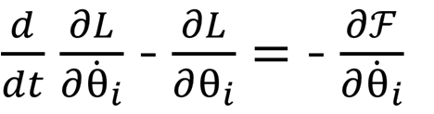

We then obtain (θ1,ω1, θ2, ω2) as a function of time. Through this, we graph the angle, angular velocity, angular momenta, and kinetic energies for each of the spinners.

For the method where we used “magnetic charges”, our goal initially was to model the spinners in a way that reflected the properties of magnets. Initially, I tried to model each magnet as a magnetic dipole.

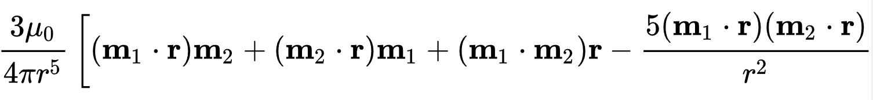

Using the formula for magnetic dipole-dipole interaction in equation 8, the force at each magnet would be calculated. However, this led to inaccurate motions in our model, such as attraction even with the position of the magnets should lead to repulsion. There was also extreme spikes in angular speed, leading to the violation of energy conservation.

On an attempt to prevent such inaccurate representation, we determined that representing a physical magnet with a single vector would lead to inaccurate forces in close distances, which was probably why our model was inaccurate. As a result, we attempted to triple integrate the physical magnet into an even distribution of magnetic dipole vectors.

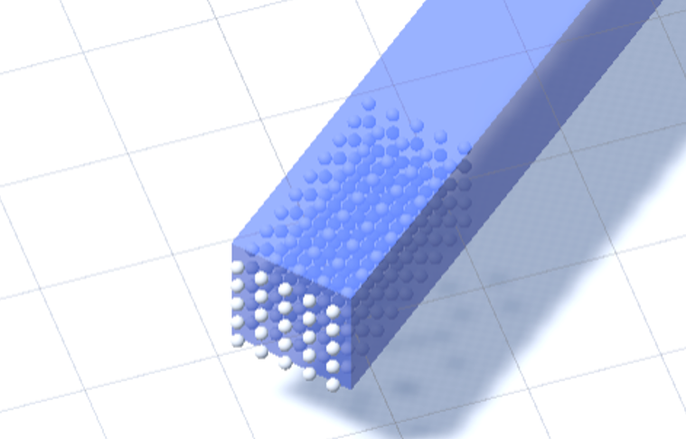

However, this inefficient integration method made our program run extremely slow as the time complexity was inefficient, and this would often crash.

Finally, we decided to model each magnet as simple “magnetic charges”, where each magnet would have two points, one to represent the south and the other to represent the north pole. The points would then follow magnetic point interaction formula.

Using Unity’s physics engine, we apply a use the AddForceAtPosition and RigidBody function to run our model.

**Results**

For our model with the linear torque, we had much smoother and reliable results.

From the angle graph, we can see that there is an oscillation effect where the rate of change of angle alternates between a fast speed and a slow speed, and we see that the coupled spinners have exactly opposing angles.

Through the graph of angular speed, we can see that the speed oscillates for the spinners, and their oscillation is at the same frequency and also identical wavelengths, just separated with a decreasing offset.

The graphs are separated into f = 0 or f = 0.005. When there is no friction in the system, energy is conserved as there is no non-conservative force so our total energy is constant. In the system with friction, our total energy decreases. Regardless of the presence of friction, we can model the kinetic and potential energy through sinusoidal graphs.

The graphs of angular momentum suggest that regardless of friction, angular momentum is not constant and it oscillates and a sinusoidal curve. With friction, the amplitude of the wave stays constant, but with friction, the amplitude of the wave decreases gradually.

In our simulation for magnetic point charges, the general motions are captured in the simulation but we obtain unsmooth graphs instead.

(This is a really bad graph ill try to get a better one)

Despite the jagged, lines, we can see that the trends in this angular velocity graph is similar the angular speed graph obtained with the first model, with both having oscillations and spinners having an offset from each other.

**Conclusion**

Because angular momentum consistently changes regardless of friction, we conclude that angular momentum is not conserved between magnetic spinners. This agrees with our early experimentation. A possible explanation of why angular momentum is not conserved is due to fact that there are multiple pivot points, one on each spinner. An example of angular momentum being decreased is when one spinner on the right rotates counterclockwise at positive momentum, while the spinner on the left is initially at rest. As one of the magnets on the right spinner reaches the left spinner, the left spinner starts to rotate clockwise at negative momentum, which decreases the overall angular momentum. An opposite effect could also be observed to increase the total angular momentum.

We also conclude that the use of a linear torque model results in smooth sinusoidal graph with equal frequencies for both spinners, while the use of a “magnetic charge” model results in unequal frequencies and unsmooth graphs.

**Future Studies**

Our torque model could be improved by adjusting the constants so that they align with real-life experimentation. Additionally, the linear fit of our graph is considerably low, although the trends are shown.

For the model with magnetic formulas, the model could be improved by getting the potential energy of magnets and converting that into a Lagrangian to get our equations of motion like in the other model.

**References**

**Appendix**

Put all code n data here n photo of unity setup